**BÁO CÁO THỰC HÀNH LẬP TRÌNH HƯỚNG ĐỐI TƯỢNG – LAB 05**

**Họ và tên: Trần Đại Hiệp**

**MSSV: 20226081**

*1.1.1 Create class AWTAccumulator*

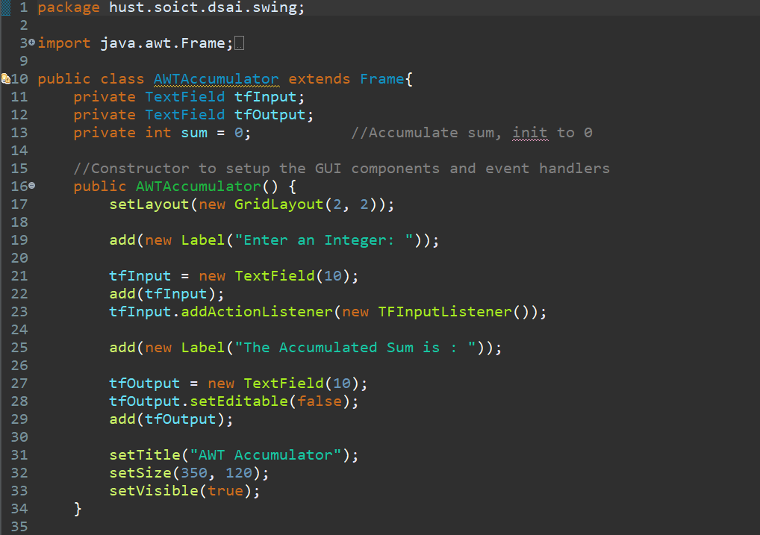

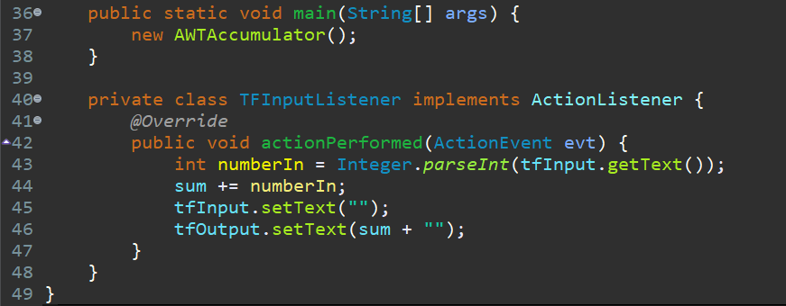

* Results:

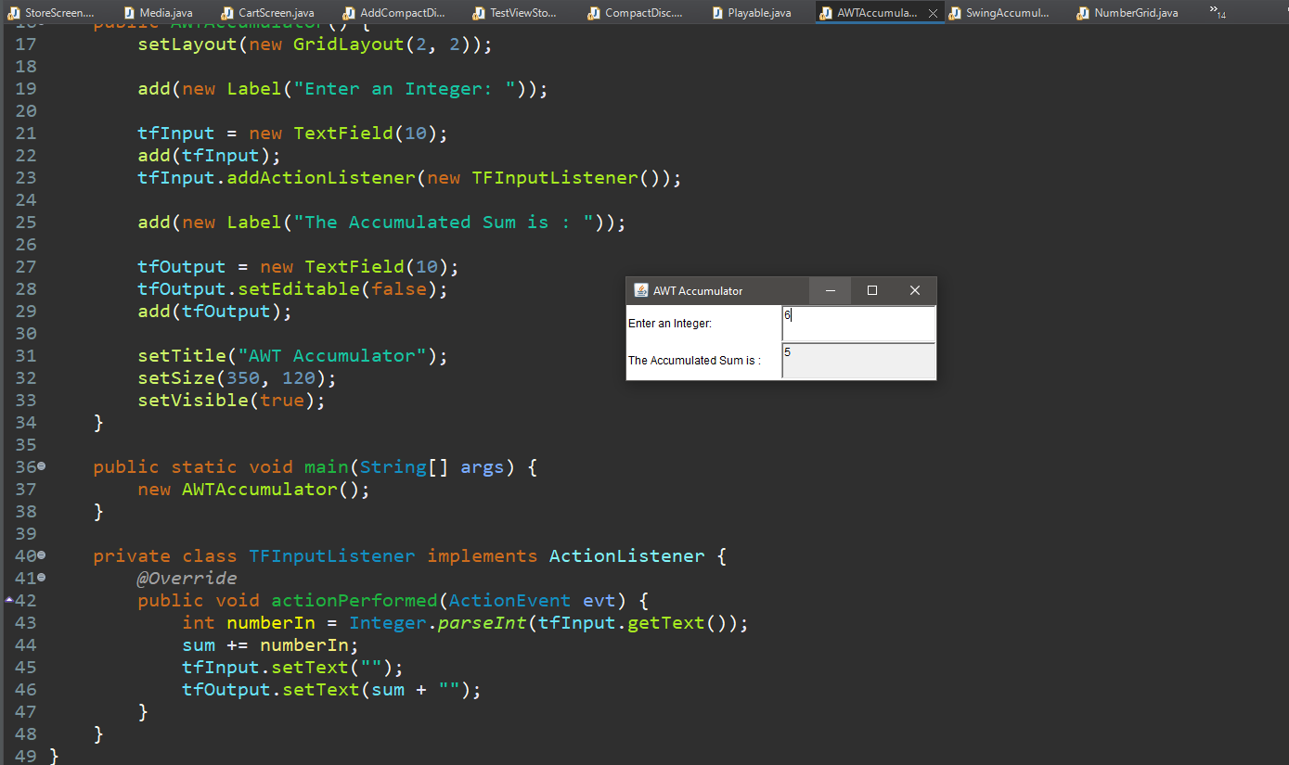

*1.2.1 Create class SwingAccumulator*

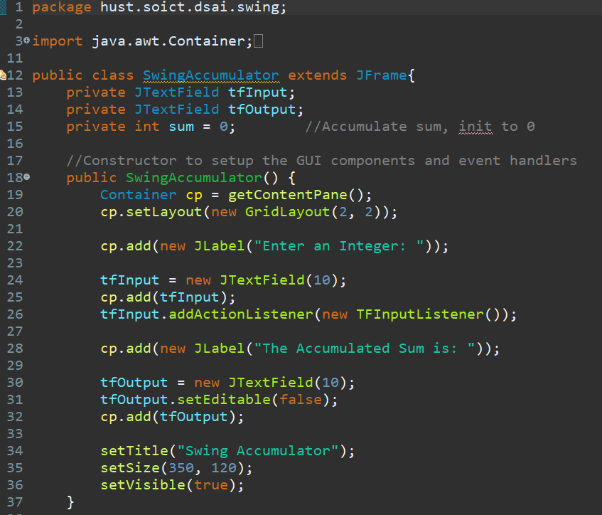

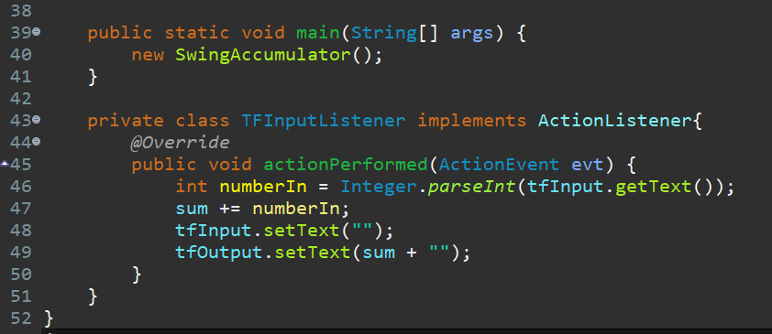

* Results:

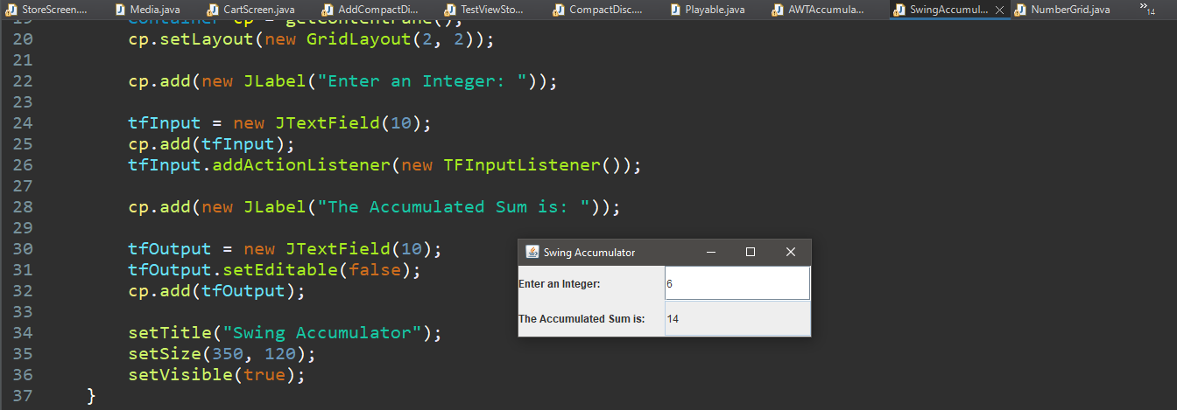

*2.2.1 Create class NumberGrid*

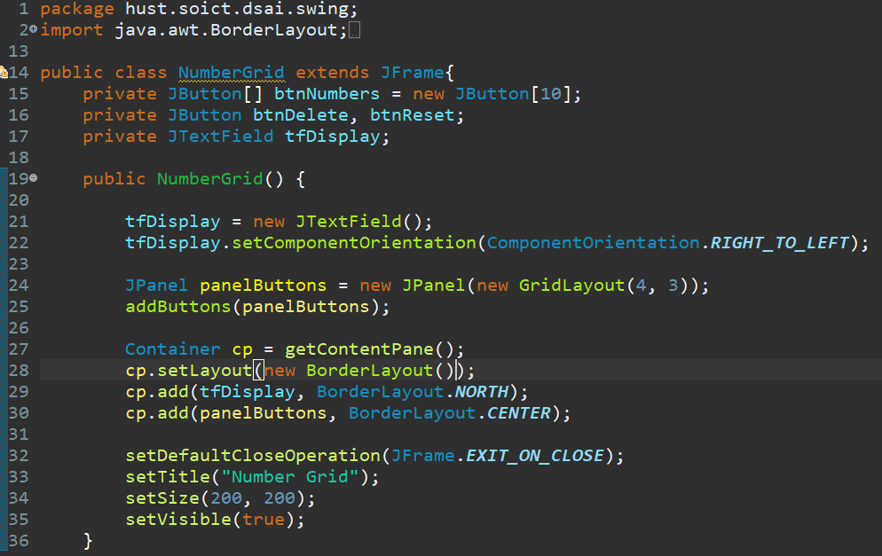

*2.2.2 Adding buttons*

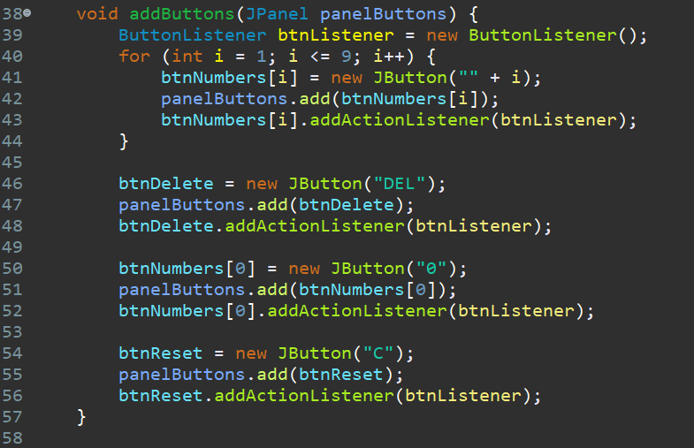

*2.2.3 Complete inner class ButtonListener*

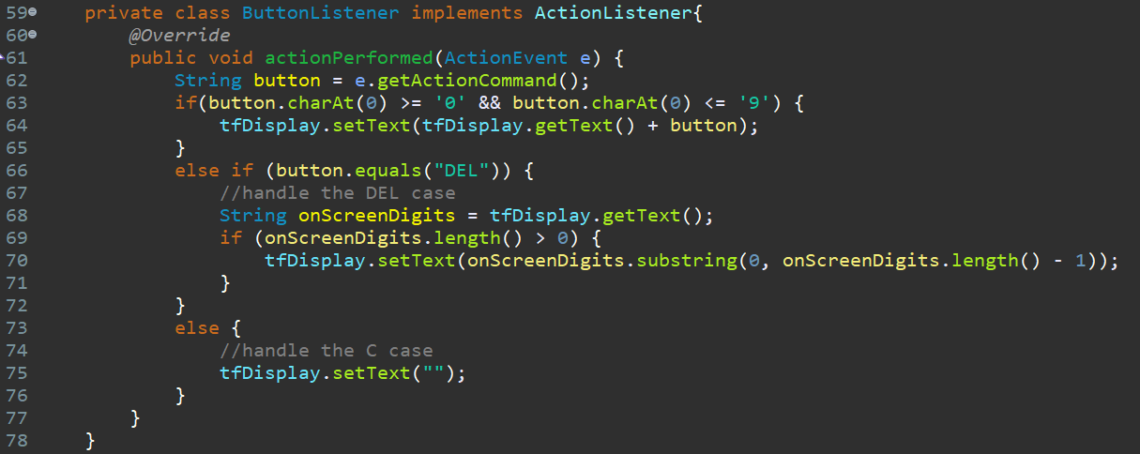

* Results:

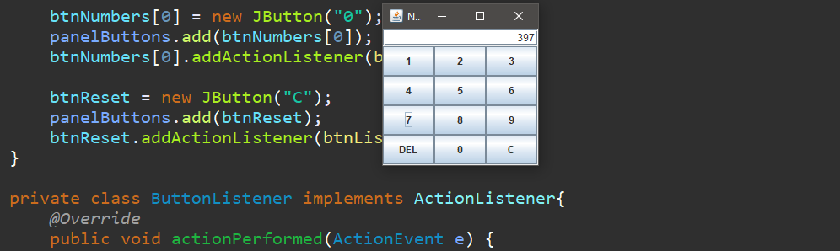

*3. Create a graphical user interface for AIMS with Swing*

*3.1.1 Create StoreScreen class*

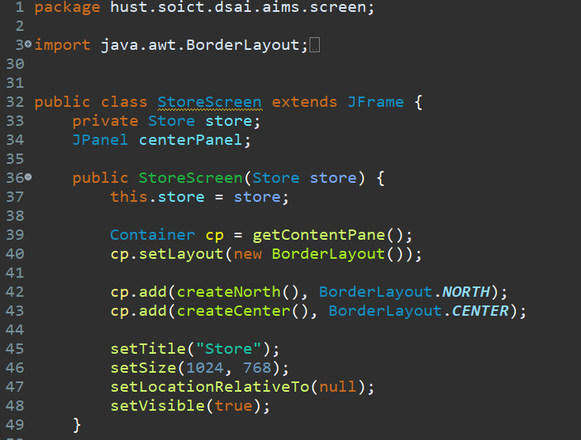

*3.1.2 The NORTH component*

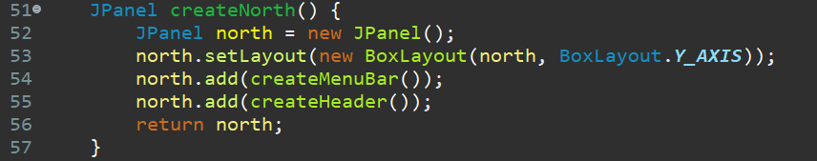

*3.1.2.1 Create method createMenuBar()*

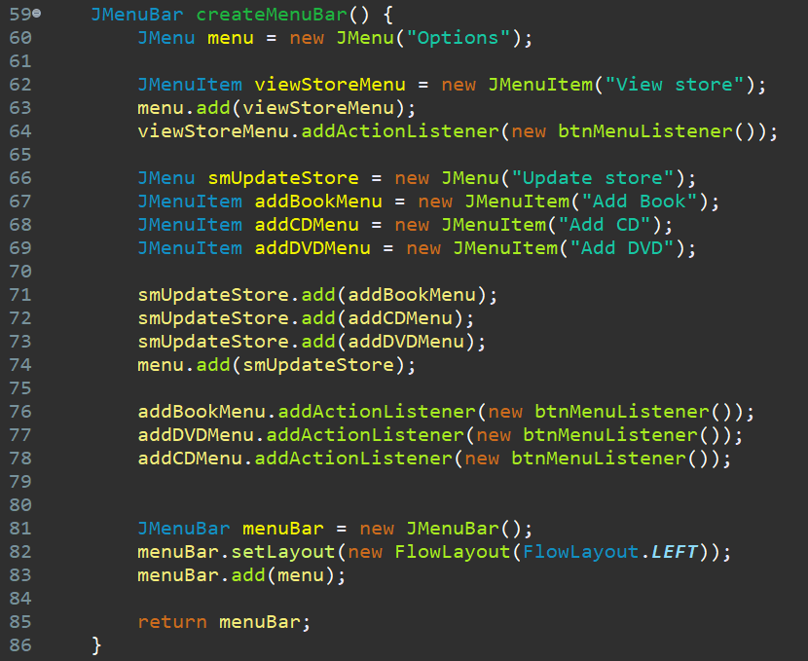

*3.1.2.2 Create method createHeader()*

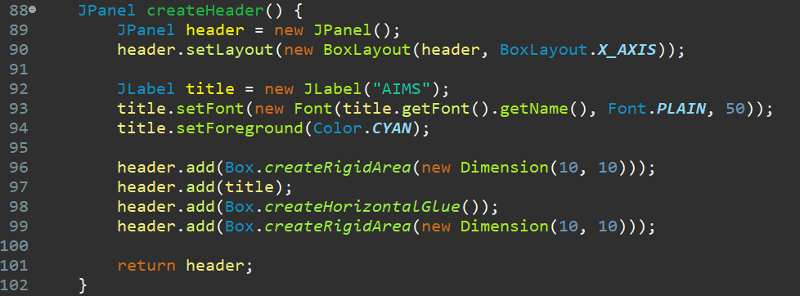

*3.1.3 The CENTER components*

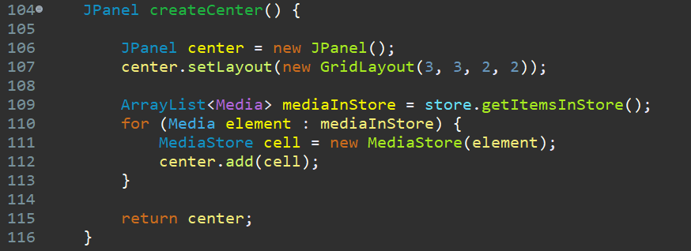

*3.1.4 The MediaStore class*

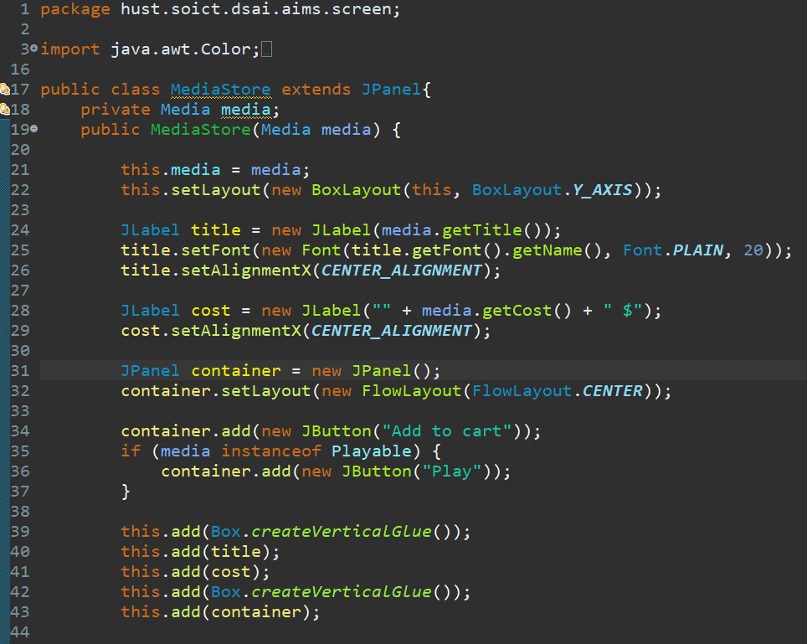

*3.1.5 Putting it all together*

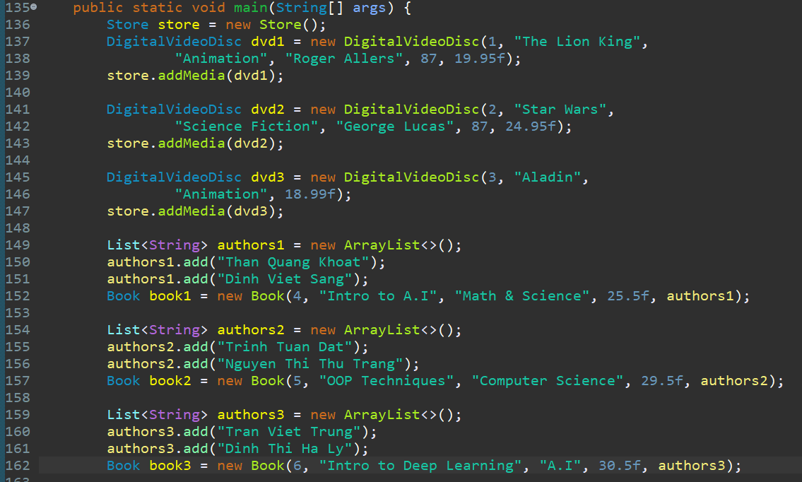

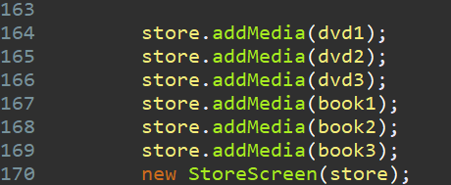

*3.1.6 Test run*

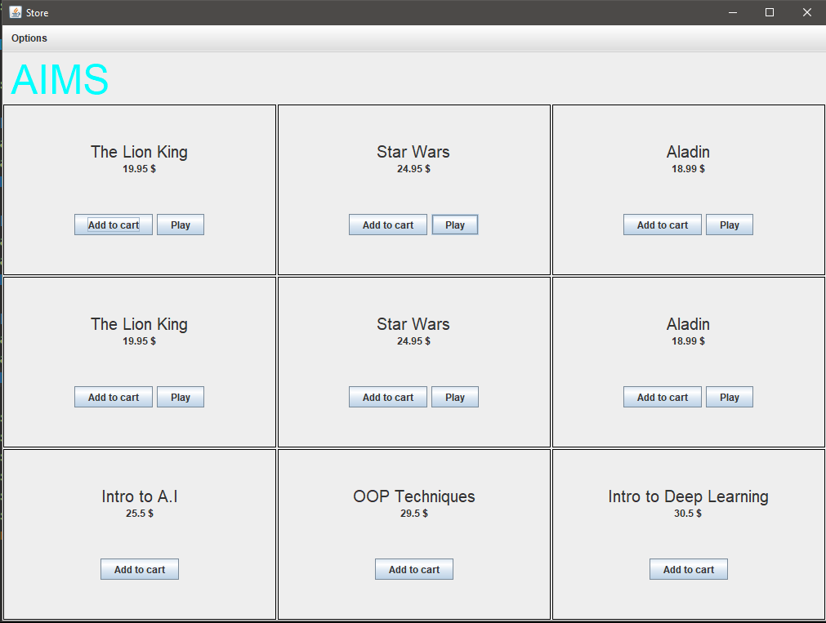

*4. JavaFX API*

*4.1.1 Create FXML file*

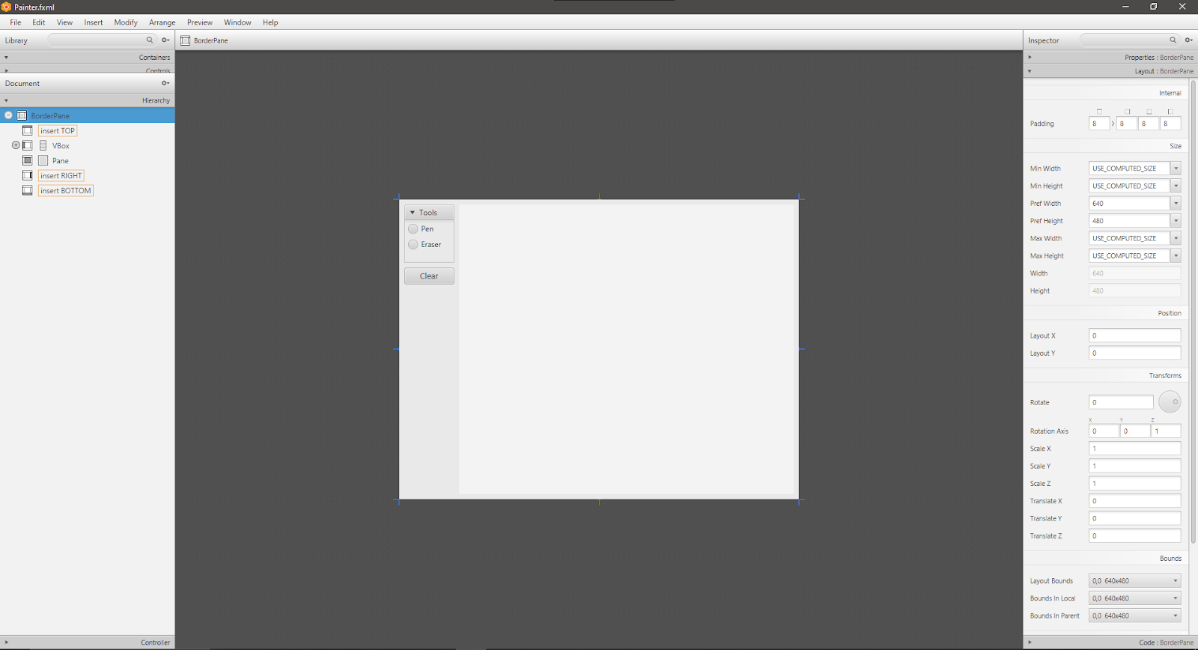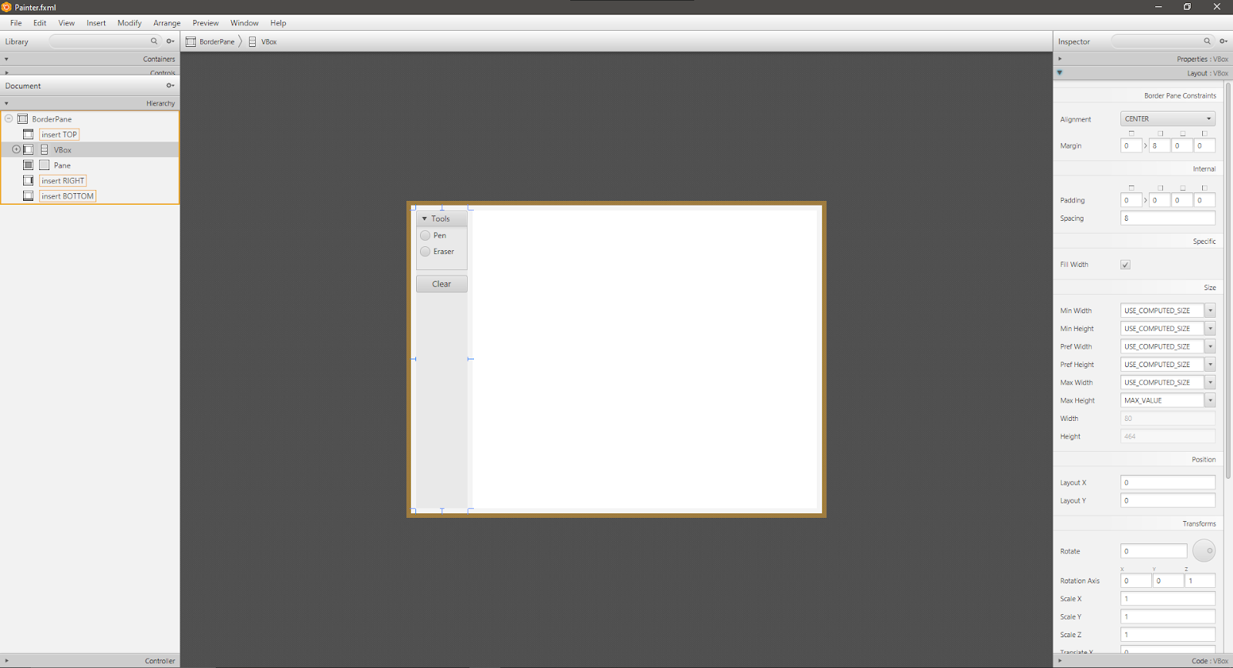

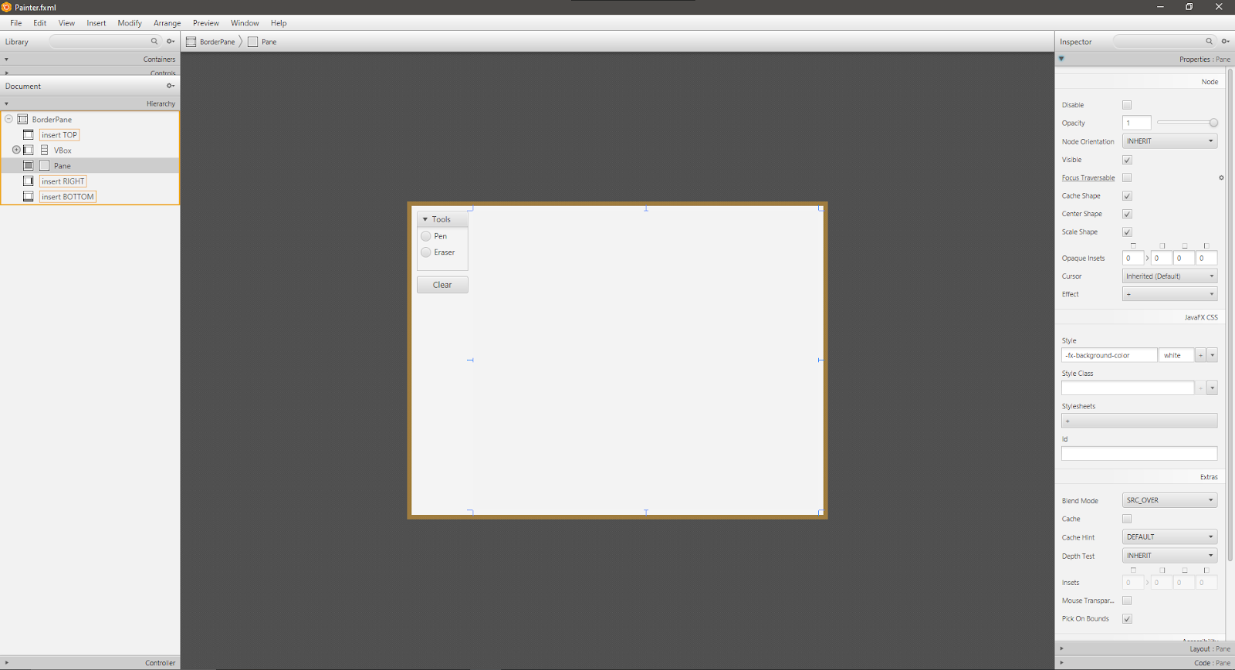

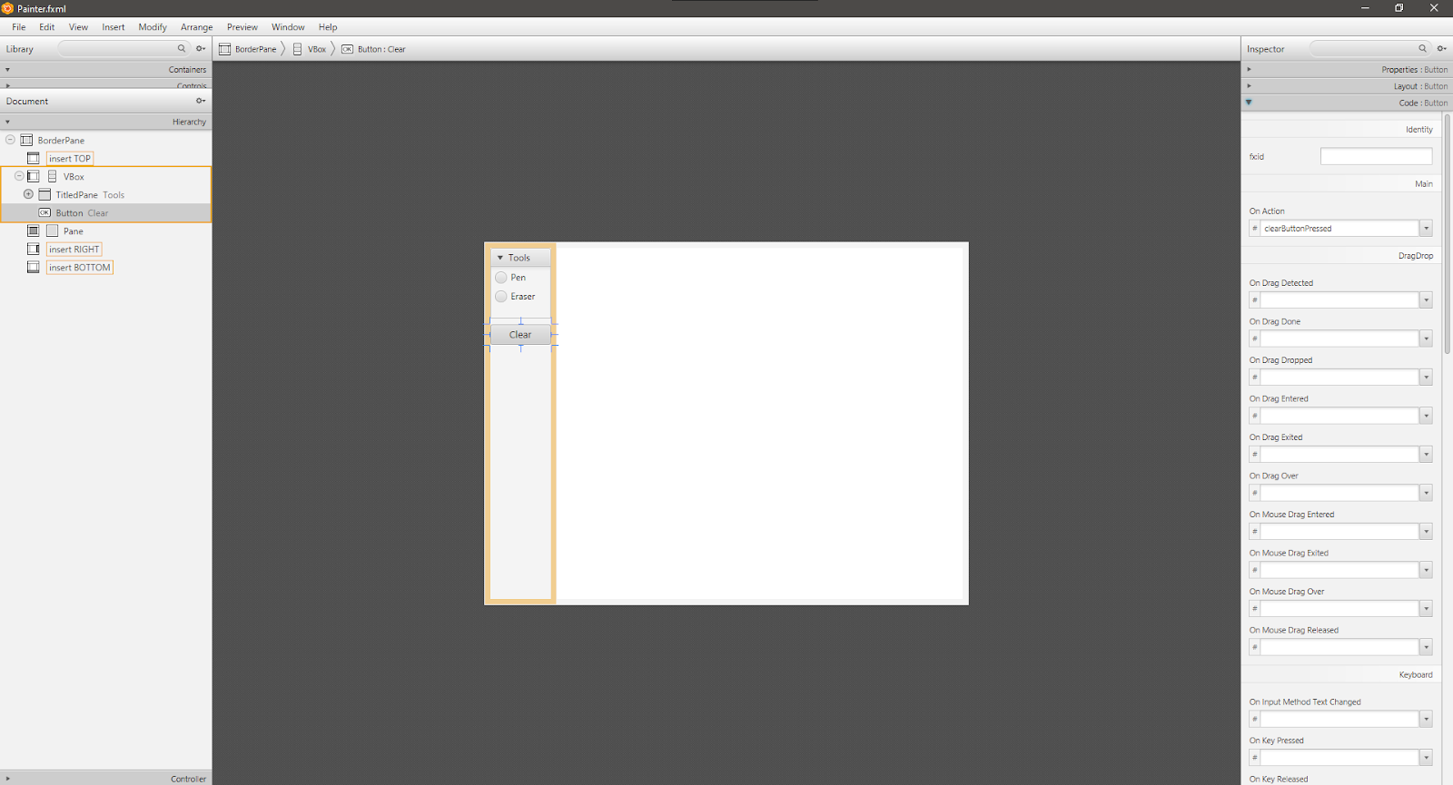

*4.2 Create the Controller class*

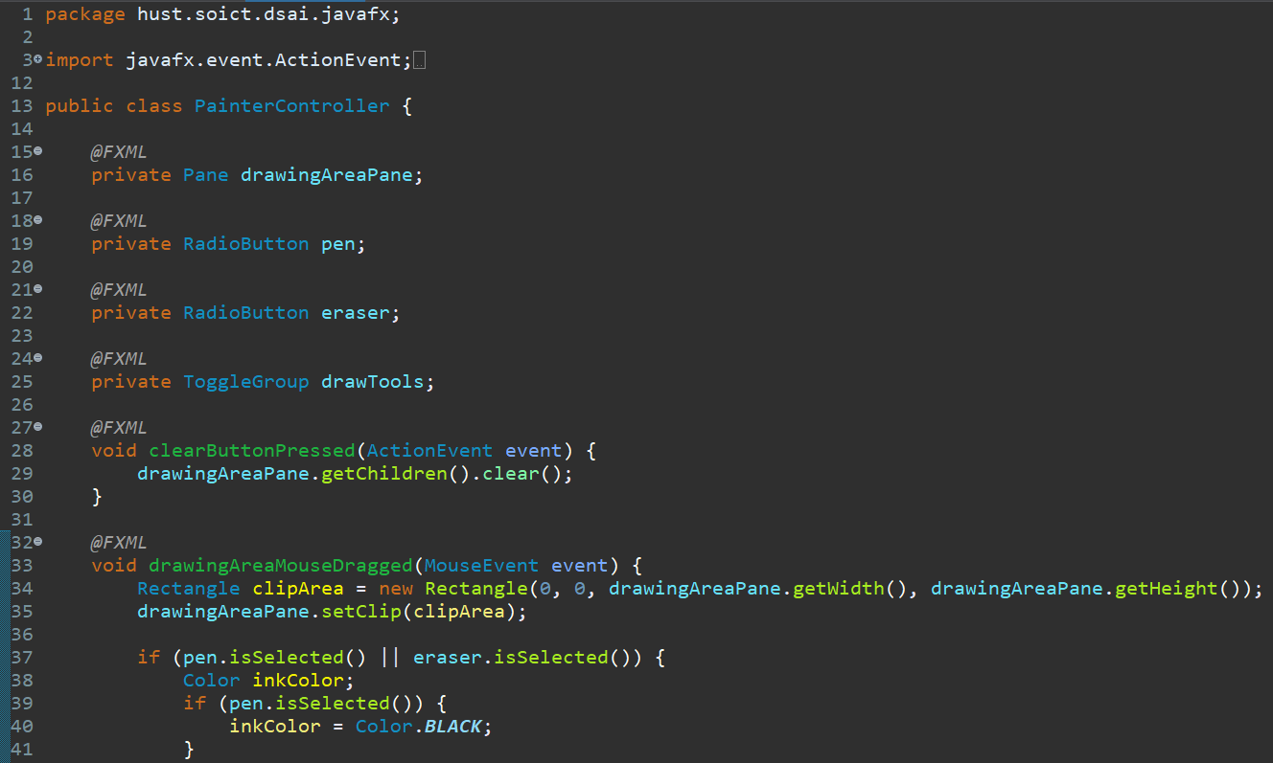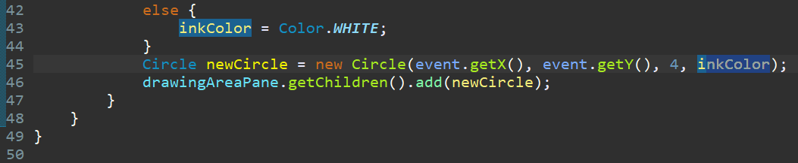

*4.3 Create the application*

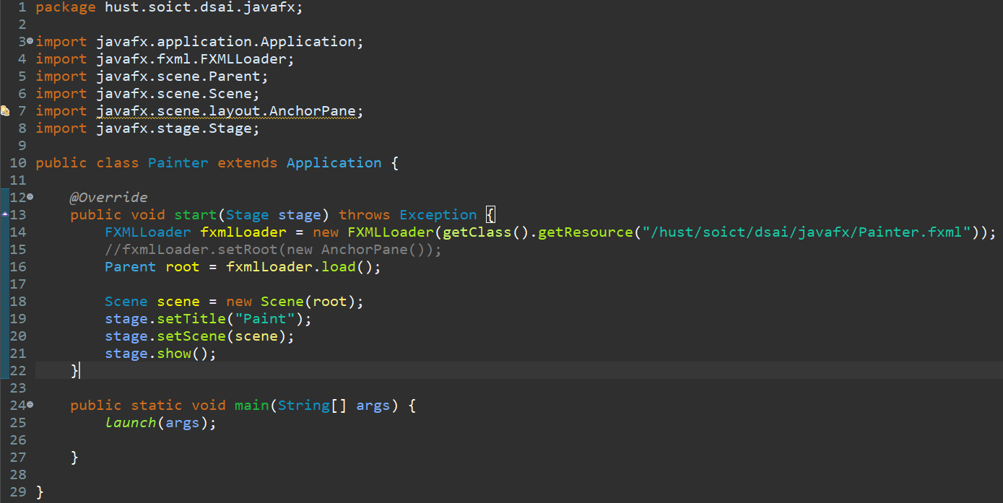

*4.4 Erasers*

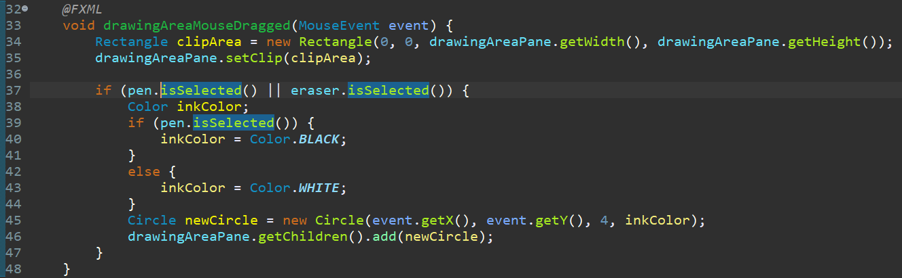

*4.5 Results*

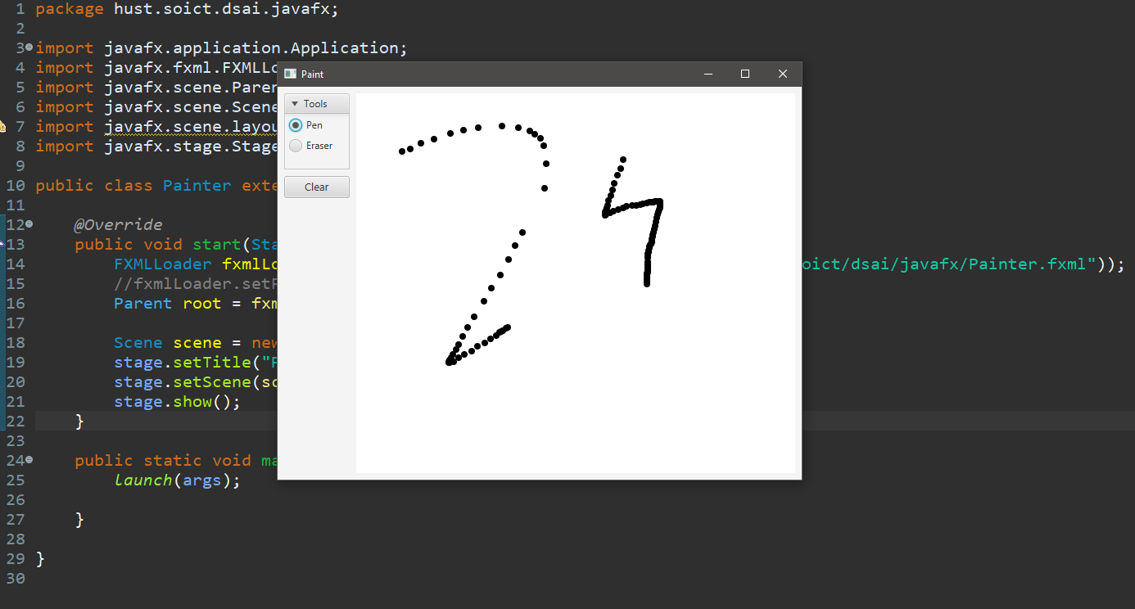

*5. Setting up View Cart Screen with SceneBuilder*

*5.1 Setting up BorderPane*

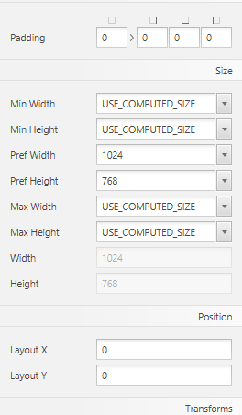

*5.2 Setting up the Top area*

|  |  |
| --- | --- |
| Step 1 | Step 2 & 3 |
|  |  |

*5.3 Setting up the CENTER area*

*5.3.1 Step 1: Drag VBox into CENTER area*

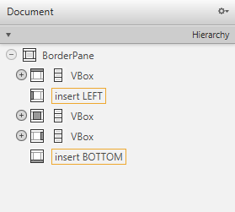

*5.3.2 Step 2, 3, 4*

|  |  |  |
| --- | --- | --- |
| Step 2 | Step 3 | Step 4 |
|  |  |  |

*5.4  Setting up the RIGHT area*

*5.4.1 Step 1: Drag a VBox into the RIGHT area*

|  |  |
| --- | --- |
|  |  |

*5.4.2 Step 2 and 3*

|  |  |
| --- | --- |
| Step 2 | Step 3 |
|  |  |

*5.4.3 Step 4 and 5: Add another Label into HBox*

|  |  |
| --- | --- |
| **Step 4** | **Step 5** |
|  |  |

*6. Integrating JavaFX into Swing Application - The JFXPanel class*

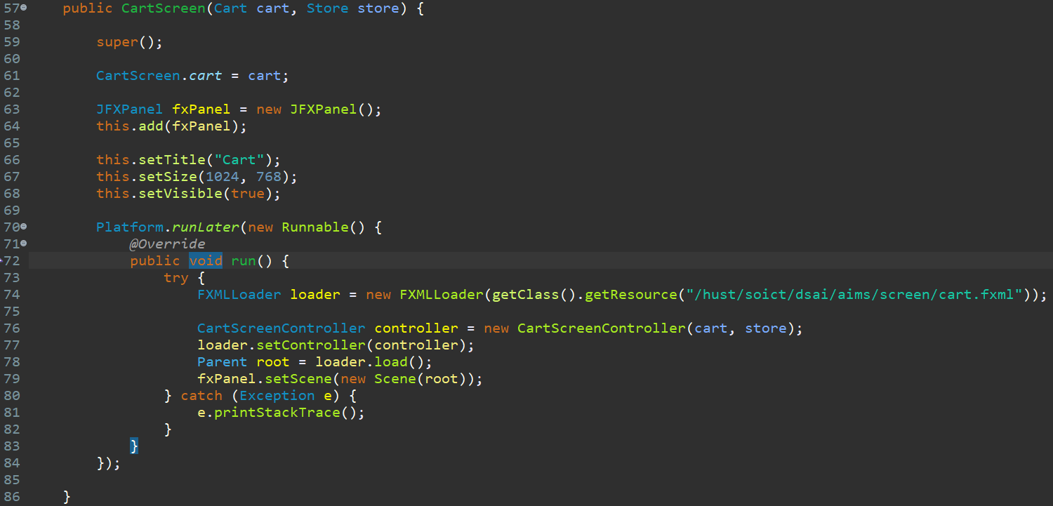

*6.1 Run result*

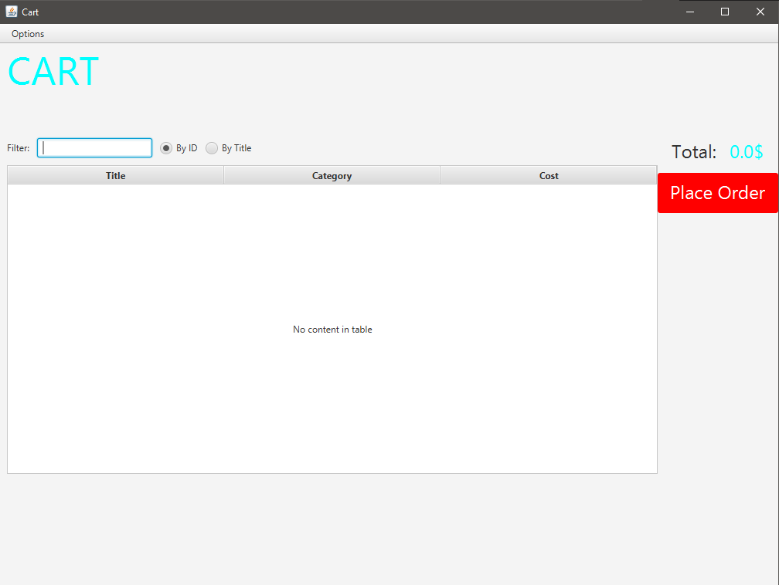

*7 View items in the cart - JavaFX’s data-driven UI*

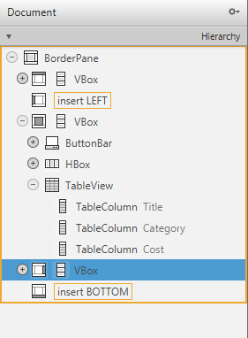

*7.1 Create CartScreenController*

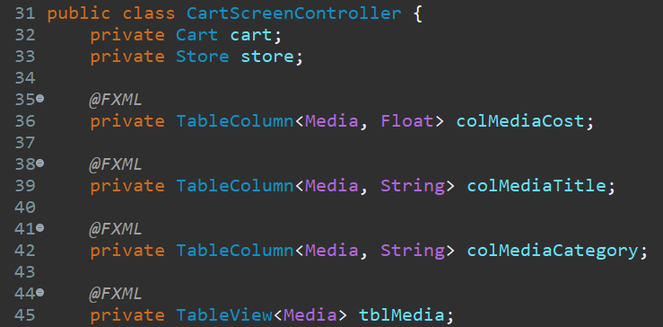

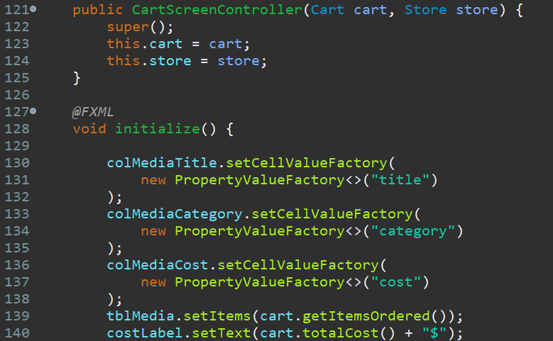

*8. Updating buttons based on selected item in TableView - ChangeListener*

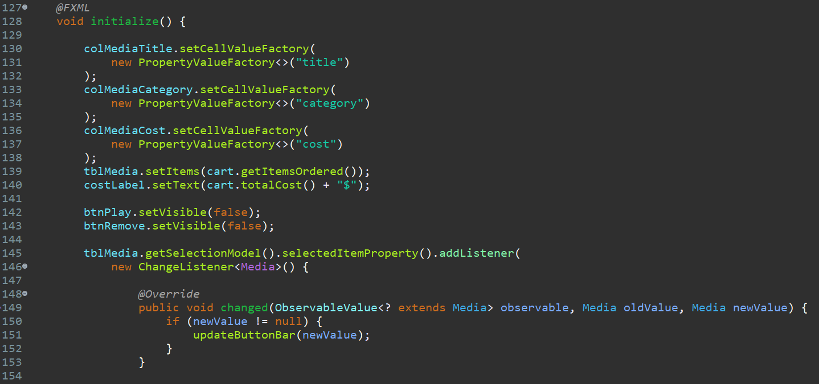

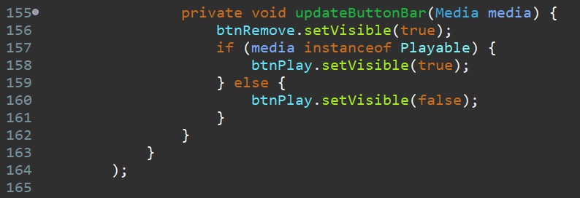

*9. Deleting a media*

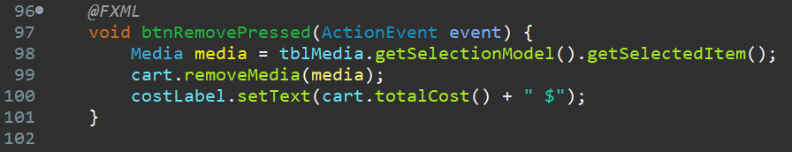

*10.  Filter items in cart - FilteredList*

|  |  |  |
| --- | --- | --- |
| TextField | RadioButton “By ID” | RadioButton “By Title” |
|  |  |  |

*10.1 showFilteredMedia() implementation*

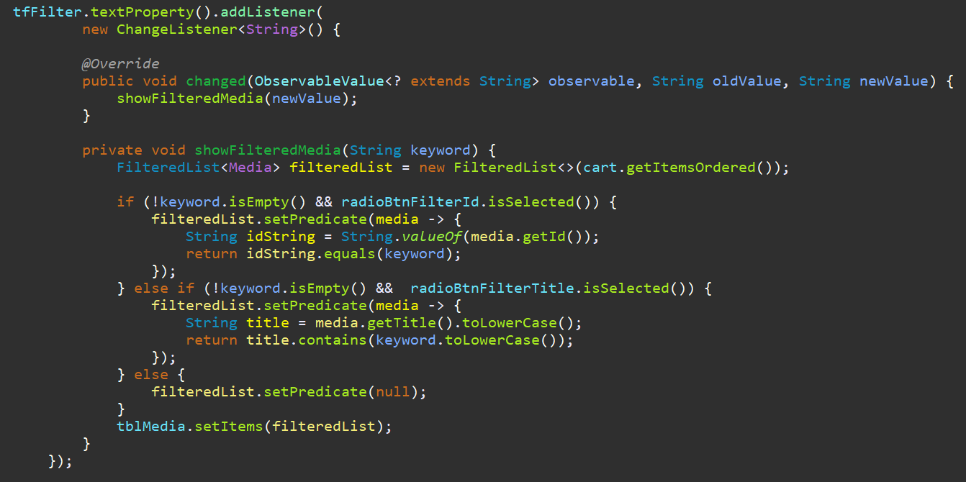

*11.  Complete the Aims GUI Application*

*11.1  StoreController class*

*11.2 ItemController class*

*11.3 AddBookController class*

*11.4 AddCompactDiscController class*

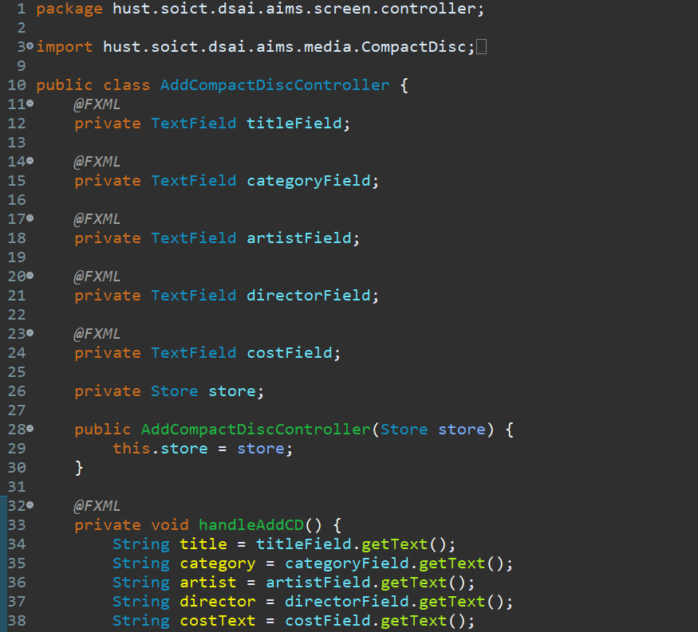

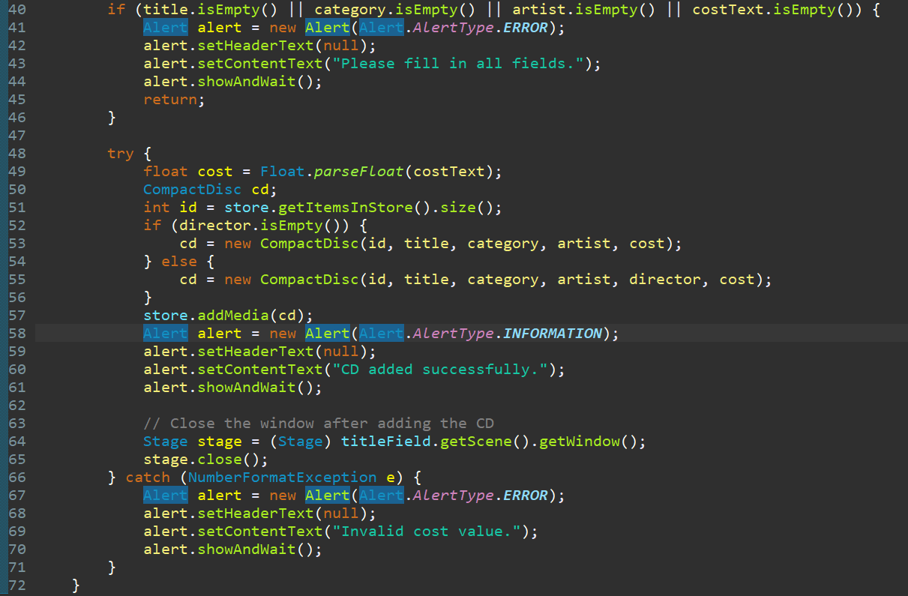

*11.5 AddDVDController class*

*11.6 ItemController class*

*11.7 Additions to the CartScreenController*

*11.8 Run results*

**Notes: If you want to run, please run the TestViewStore.java in AimsProject.hust.soict.dsai.aims.screen.controller**

*12. Check all the previous source codes to catch/handle/delegate runtime exceptions*

*13 Create a class which inherits from Exception*

*13.1 Create PlayerException class*

*13.1.1 (Optional) create LimitExceededException*

*13.2 Raise PlayerException in Play() method*

*13.2.1 Raise PlayerException in Play() method in DigitalVideoDisc class*

*13.2.2 Raise PlayerException in Play() method in Track class*

*13.3 Update play() in the Playable Interface*

*

*15 Modify equals() method of Media class*

*17 Update Aims class diagram*

